PROJECT REPORT
Smart Campus Facility & Lab Booking System (CFBS)

**Submitted by:**
**Name:** Aniket Thakur
**Registration no:** 25BAI11190
**Academic year:** 2026-2027
**Subject:** CSE2006 - Programming in Java

GitHub Repository:
https://github.com/thakuraniketsingh16-cloud/CampusFacilityBooking

Introduction

The Smart Campus Facility & Lab Booking System (CFBS) is a comprehensive desktop application developed to streamline the administration and reservation of shared physical infrastructure within educational institutions. Built purely using Java SE and Java Swing, the application replaces manual logbooks with a centralized, automated digital dashboard. It facilitates the scheduling of high-tech computing labs, grand auditoriums, and sports arenas while enforcing strict, role-based business rules to ensure fair usage across the campus.

Problem Statement

Manual management of shared physical infrastructure in modern educational institutions often leads to administrative inefficiencies. Common challenges include frequent double-bookings, the inability to systematically enforce fair-usage time quotas (e.g., preventing a student from
monopolizing a lab all day), and unauthorized access to restricted facilities (e.g., students booking grand auditoriums without faculty endorsement). There is a critical need for an automated, rule-driven system to schedule, validate, and manage these resources seamlessly without the massive overhead of complex enterprise software.

Functional Requirements

- User Authentication & Profiles: The system must allow users to operate under specific profiles (Student vs. Faculty).
- Facility Catalog: The system must display a list of all available facilities, their capacities, types,
and specific hardware/features.
- Booking Engine: The system must allow users to select a facility, date, and time slot to create a reservation.
- Collision Detection: The system must strictly reject overlapping bookings for the same
facility.
- Quota Enforcement: The system must reject student bookings exceeding 2 hours and faculty bookings exceeding 6 hours per session.
- Auditorium Access Control: The system must prevent students from directly booking grand
auditoriums (capacity > 150) without faculty endorsement.
- Cancellation Module: Users must be able to cancel their own active bookings.
- Analytics & Reporting: The system must generate real-time utilization reports grouped by facility and department.

Non-functional Requirements

- Usability: The interface must feature a modern, intuitive Dark Mode GUI for reduced eye strain and easy navigation.
- Performance: File read/write operations must be optimized to ensure instant UI
responsiveness during booking validations.
- Reliability: Data must be persistently saved to local storage immediately upon any modification to prevent data loss.
- Portability: The application must run on any OS (Windows, macOS, Linux) with a standard
Java Runtime Environment (JRE 8+) without requiring external database installations.

System Architecture

The application employs a monolithic desktop architecture utilizing a lightweight Model-View-Controller (MVC) pattern contained within a unified codebase:
- Model (DataStore, Facility, User, Booking): Handles data encapsulation, flat-file I/O operations (campus_data.txt), and core business logic (collision detection).
- View (CampusBookingGUI): Built with Java Swing, overriding the UIManager to render a
custom CrossPlatform Dark Theme.
- Controller (Action Listeners): Bridges user inputs from the GUI to the DataStore methods, returning formatted results or custom exceptions (CampusBookingException).

Design Diagrams

Use Case Diagram

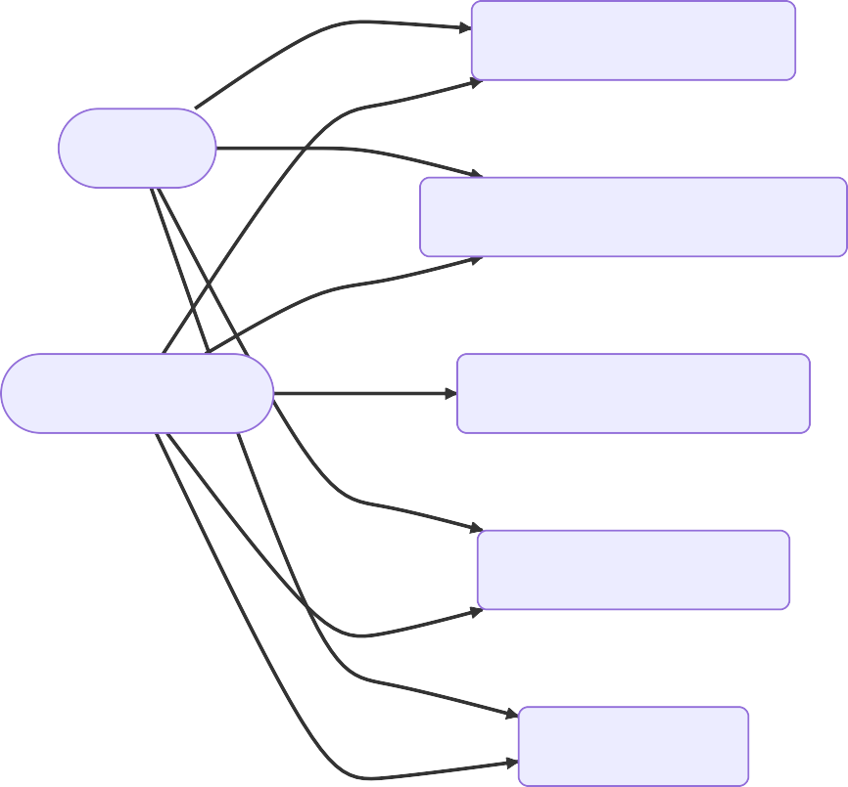
CFBS System

View Facility Catalog
Student
Book Computing Lab / Court
Faculty Member
Book Grand Auditorium
Cancel Own Booking
View Analytics

Workflow Diagram

Launch Application
Auto-load DataStore
Select Active Profile

Choose Action
Enter Booking Details
Save to flat-file
Generate Booking ID

View Catalog New Booking View Analytics
Display Facilities
Process Stream API Aggregations

Validation Engine

Overlap/Quota Error Valid
Throw Exception & Reject

Show Success Confirmation

Sequence Diagram


Check
createBooking(...)
Validate Quot
a & Permissions
Overlaps
CampusBookingGUI
DataStore
campus_data.txt
User
save() (Write to Disk)
CampusBookingGUI
ooking Object
Returns Booking Object
DataStore
Instantiate B
alt
Clicks "Reserve Slot"
[Valid Request]
campus_data.txt

Show Success Message
[Invalid Request] throws CampusBookingException
User
Show Error Dialog

Class Diagram

SSyynnttaaxx eerrrorror iinn grraphhpag
mmeerrmmaaiidd vveerrssiioonn 99.. 44.. 33

ER Diagram (Flat-File Representation)

places

hosts
USER
string | ID | PK
string | Role
string | Name
string | Department

FACILITY
string | ID | PK
string | Type
int | Capacity
string | Location

BOOKING
string | BookingID | PK
string | UserID | FK
string | FacilityID | FK
date | Date
time | StartTime
time | EndTime
string | Status

Design Decisions & Rationale

- Single-File Architecture: To satisfy strict academic submission constraints (ensuring it can be compiled out-of-the-box via a single javac Main.java command).
- Flat-File Persistence (campus_data.txt): Chosen over JDBC/MySQL to guarantee 100% portability. Anyone testing the project doesn't need to configure a database server; the system automatically seeds its own demo data if the file is missing.
- Java Swing with Custom UIManager: Selected over JavaFX because Swing is deeply
integrated into standard JDKs. A manual Dark Mode was engineered by overriding UIManager properties globally to achieve a modern aesthetic without third-party libraries (like FlatLaf).
- Java 8 Stream API: Used extensively in the Analytics module to aggregate, group, and sort
large collections of bookings concisely and efficiently.

Implementation Details

- Core Concepts Used: The project rigorously applies Object-Oriented Programming (OOP). Facility and User are abstract classes enforcing polymorphism (e.g., dynamically resolving getMaxBookingHours() based on whether the object is a Student or FacultyMember).

- Exception Handling: A custom hierarchy of checked exceptions (CampusBookingException,
SlotUnavailableException, InvalidInputException) ensures predictable error recovery.
- Date & Time API: Utilizes the modern java.time.LocalDate and LocalTime classes for robust interval math and overlap detection.

Screenshots / Results

(Note: Replace these placeholders with actual screenshots from the application)

Dashboard & Analytics
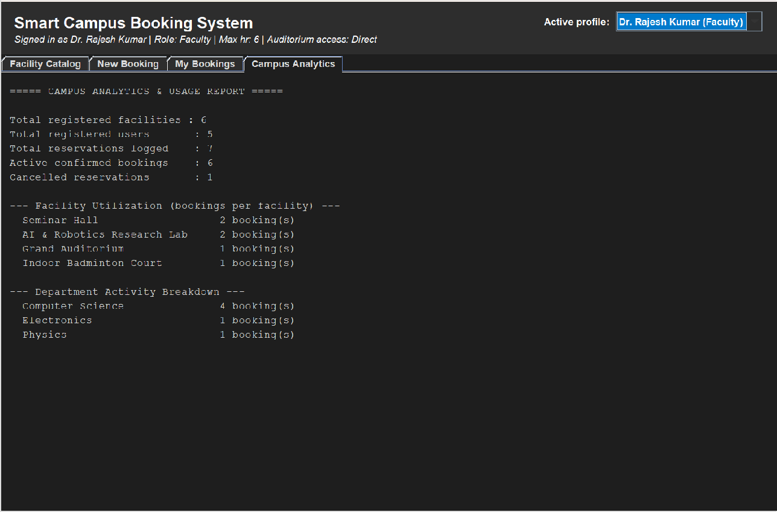

Facility Booking & Validation

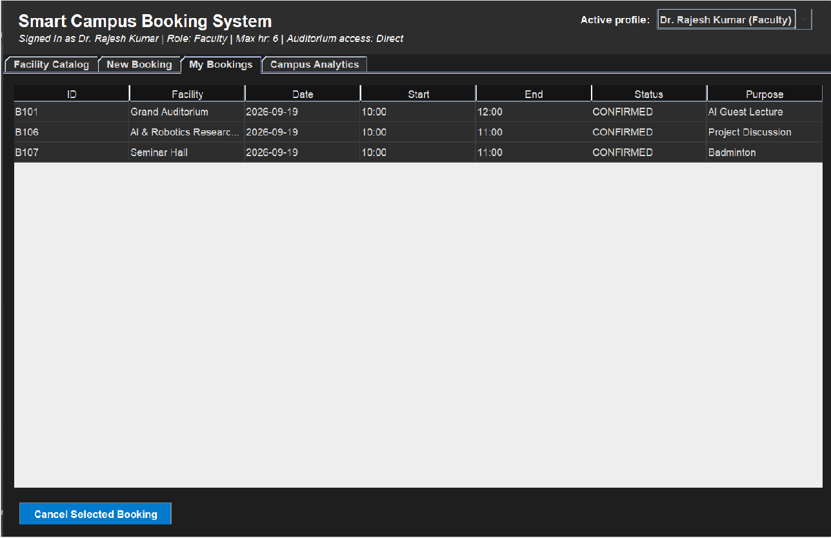

Testing Approach

- Automated Self-Diagnostics: A built-in class (TestHarness) can be triggered via java Main
--test. It runs headless boundary tests simulating quota overflows, time overlaps, and auditorium permission denials to ensure core logic integrity without human intervention.
- Manual GUI Testing: Exhaustive black-box testing was conducted by creating conflicting
bookings through the UI, verifying that error messages format correctly, and confirming that cancellations immediately free up the corresponding time slots.

Challenges Faced

- Dark Mode Implementation: Forcing legacy Java Swing components (like JTable headers and JScrollPane borders) to conform to a dark theme natively required deep manipulation of obscure UIManager properties.
- Collision Logic: Designing a mathematically sound overlap detection algorithm that handles edge cases (e.g., back-to-back bookings where EndTime A exactly equals StartTime B) required careful use of .isBefore() and .isAfter() constraints.
- Single-File Clutter: Managing Model classes, Data I/O, custom Exceptions, and complex GUI layouts within a single Main.java file demanded extremely strict structural organization and commenting.

Learnings & Key Takeaways

- Mastered the implementation of Java 8 Stream API for complex data aggregations and filtering.
- Gained profound understanding of the java.time package and temporal logic.
- Learned how to effectively decouple business logic (Validation Engine) from the presentation layer (Swing GUI) even within tightly constrained single-file architectures.
- Developed a strong grasp of file I/O operations and robust data-parsing techniques.

Future Enhancements

- Database Integration: Upgrading the storage backend from flat-file I/O to a robust relational database (MySQL/PostgreSQL) using JDBC.
- Email Notifications: Integrating the JavaMail API to send automated booking confirmations and cancellation receipts to users.
- Calendar View UI: Replacing the text-based schedule viewer with an interactive, graphical drag-and-drop weekly calendar matrix.

References

- Oracle Java SE Documentation: https://docs.oracle.com/javase/8/docs/api/
- Creating a GUI With Swing: https://docs.oracle.com/javase/tutorial/uiswing/
- Project Source Code Repository: https://github.com/thakuraniketsingh16-cloud/CampusFacilityBooking

